CS 340 Module Eight Assignment: Data Aggregation Pipeline
Student: Russell Buck
Course: CS-340-T4528
Date: June 27, 2026

This assignment demonstrates advanced MongoDB operations, including importing data, executing queries, and designing an aggregation pipeline. The goal is to analyze company data stored in the companies database and perform set-like operations using MongoDB’s aggregation framework.

Database Creation and Verification
Import Command
The following command was used to import the dataset into MongoDB:
mongoimport --db companies --collection research --file /datasets/companies.json


Result: 18,801 documents imported successfully, 0 failed.

Verification Queries
After importing, the following queries confirmed the data was loaded correctly:
js
use companies
db.research.countDocuments()
db.research.find({ "name": "AdventNet" })
Result:
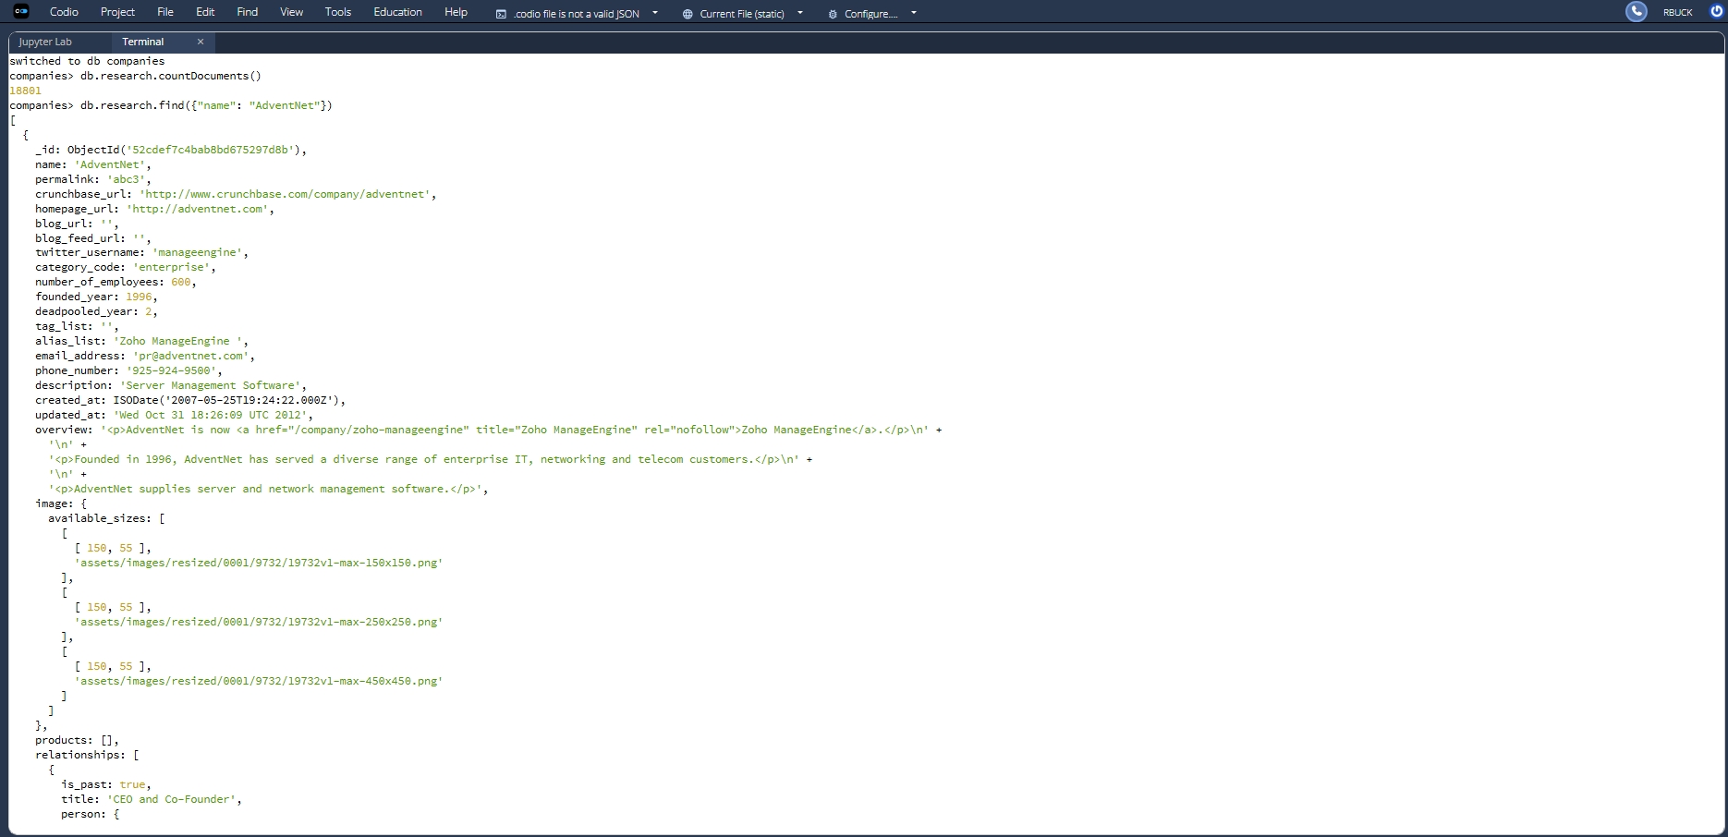
- Document count: 18,801
- AdventNet record displayed with full company details.

MongoDB Queries
Query 1 – Companies Founded After 2010
js
db.research.find(
{ founded_year: { $gt: 2010 } },
{ name: 1, _id: 0 }
).sort({ name: 1 }).limit(20)
Purpose: Lists the first 20 companies founded after 2010, ordered alphabetically.

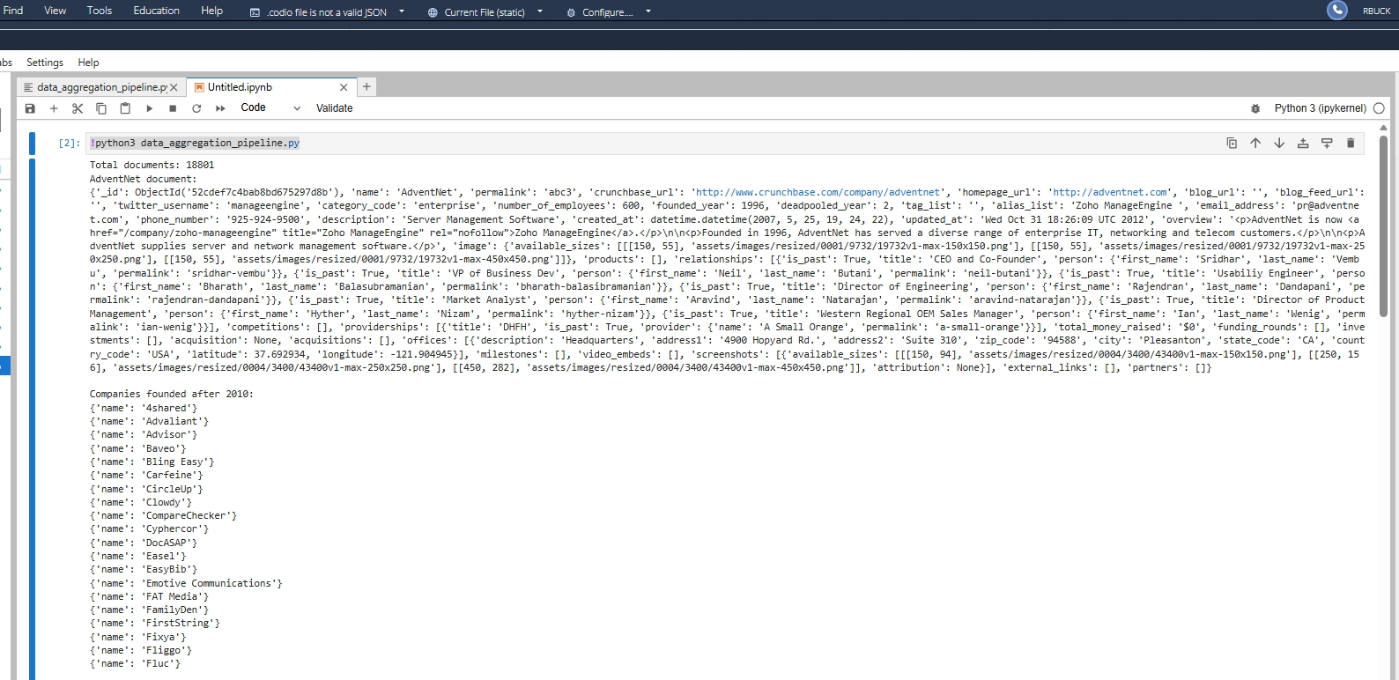
Result: Displays companies such as 4shared, Advaliant, Advisor, Baveo, and Fluc.

Query 2 – Offices in CA or TX
js
db.research.find(
{ "offices.state_code": { $in: ["CA", "TX"] } },
{ name: 1, number_of_employees: 1, _id: 0 }
).sort({ number_of_employees: -1 }).limit(20)
Purpose: Lists the first 20 companies with offices in California or Texas, sorted by employee count (largest to smallest).

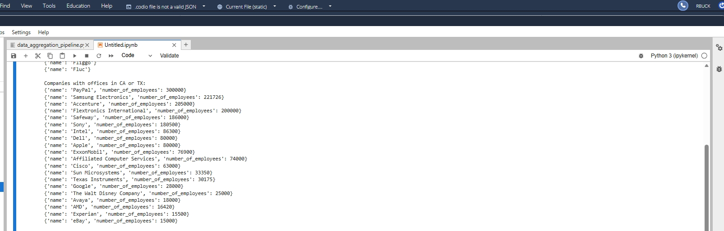 Result: Includes major companies such as PayPal, Samsung Electronics, Accenture, Intel, and Apple.
(Insert Screenshot 4 – Python output showing Query 2 results)

Aggregation Pipeline
Pipeline Code
js
db.research.aggregate([
{ $unwind: "$offices" },
{ $match: { "offices.country_code": "USA" } },
{
$group: {
_id: "$offices.state_code",
totalEmployees: { $sum: "$number_of_employees" }
}
},
{ $sort: { _id: 1 } }
])
Purpose: Calculates the total number of employees by U.S. state for all companies with offices in the United States.
Explanation of Stages:
Stage | Description
$unwind | Expands each company’s offices array into individual documents.
$match | Filters only offices located in the USA.
$group | Aggregates by state and sums employee totals.
$sort | Orders results alphabetically by state code.
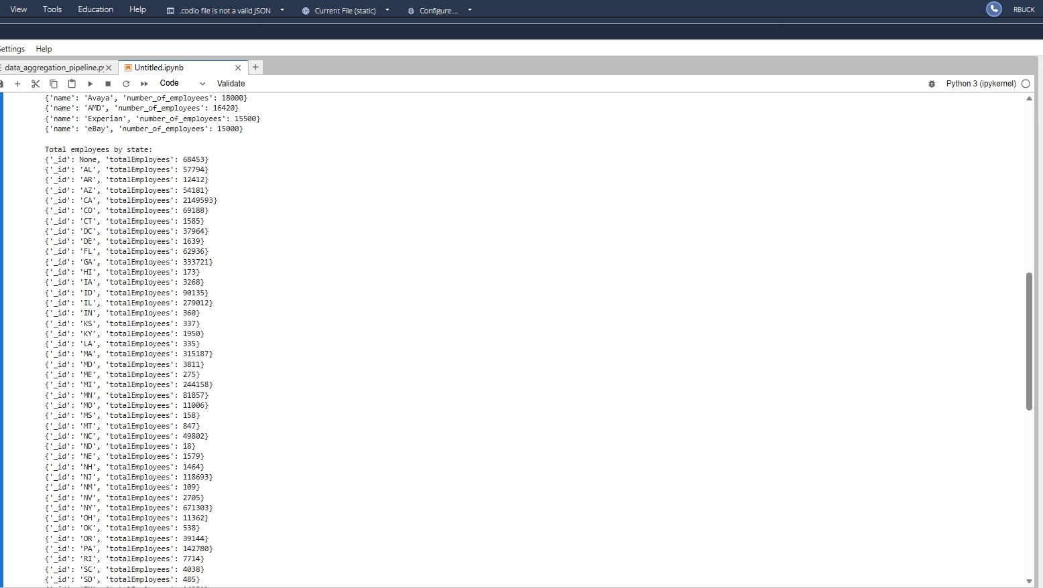
Result: Displays totals such as CA = 2,149,593 employees, TX = 393,037, NY = 671,303, and VA = 334,707.

Reflection
This exercise demonstrates how MongoDB’s aggregation framework can perform complex data analysis efficiently. By combining $unwind, $match, $group, and $sort, large datasets can be transformed into meaningful summaries. The queries and pipeline confirm mastery of advanced database operations.

